**NOTICE**

* **Students will present the Project PPT to the respective guide as per the schedule displayed by the department project coordinator/s**
* **Students should verify the contents with their respective guide in softcopy format before getting it printed/or binding it.**
* **No. of copies to be made = No. of students in the group + 1**
* **Each group must submit the Scholarly paper of their project, to department project coordinators, in IEEE format after discussion with their respective guide before getting the black book approved.**

**Guidelines for Preparation of B.E. Project Report**

(Acknowledgement: Formatting guidelines of University of Mumbai are referred)

1. Title & Cover Page <Refer Specimen A>
2. Internal Approval or Certificate <Refer Specimen B>
3. Approval or Certification <Refer Specimen C>
4. Declaration <Refer Specimen D>
5. Acknowledgements
6. Abstract or Executive Summary
7. Table of Contents
8. List of Figures
9. List of Tables
10. List of Symbols and Abbreviations
11. Introduction
12. Body of the Project & the Chapters
13. Experiments and Results
14. Conclusion and Recommendations
15. Future Scope
16. References
17. Appendices

In the above structure, the first nine pages are known as preliminary pages, and are usually numbered with the Roman numerals as I, II, III, IV, and so on, except the title page. All the

contents of the project report should be in ‘Times New Romans’ font, and the size should be 12 throughout. All the text should be left with the ‘justified’ option with line spacing of 1.5, but for

the Captions single spacing should be opted. The length of the overall document should be around 80 to 100 pages for it to be an effective project report.

**Title page**

All the letters of the title page must be capitalized, and the title page should not contain page numbers. The other aspects of the title page like the title should be like a report, and should contain the name of the organization to which the project is intended to be submitted.

Next, the course name should be followed by the student’s name, his roll number, guide’s name and designation, and at the end of the title page, organization’s logo and address should be written, as shown in the above figure.

**Declaration and Approval**

The declaration is a statement written by the student who declares that he or she has sincerely completed his or her project. The declaration statement concludes with the signature of the student.

The Approval page is also a confirmation from the head of the department, guide, and external examiner about their acceptance of the project. The approval page is endorsed with the signatures of the heads confirming their approval of the project.

**Acknowledgement**

The acknowledgement page depicts the gratitude, respect and thankfulness of the student towards the people who helped him in pursuing the project successfully and ensured successful completion and implementation of the project. In this page, the author expresses his gratitude and concern by using praising and thanksgiving words.

**Abstract**

Abstract represents a summarized report of the complete project in a very concise and informative format covering main objective and aim of the project, the background information, processes and methods used, and methodologies implemented, followed with a brief conclusion of two to three lines talking about the results and scope of the project.

The entire abstract of a project report should be written in about 250 to 350 words, and therefore, should not exceed any further.

**Table of Contents, List of Figures and Tables**

Table of contents provides a complete sketch of the title, subtitles, headings, topics and the project elements that are involved in those headings. In other words, different sections and their titles are included here.

The whole project report in a nutshell is made known in the table of contents section, and therefore, it should include the titles of the first, second and third level headers, and must give a clear picture of the report to the reader.

Similarly, a list of figures and tables helps the reader to locate diagrams, charts and tables in the document, and therefore, it should be numbered accordingly by chapter and page number. It is not necessary to indicate page numbers for symbols and abbreviations used in the document.

**The Main Body of the Project**

The main body of the project should comprise several chapters with the corresponding titles, and each page within these chapters must be numbered in numerals as page numbers. The usual way of presenting these chapters is given below.

**Chapter 1:** Introduction chapter. This chapter should contain brief background informationabout the project, the methodology implemented for problem solving and the outlines of the results and future scope of the project. It rarely contains drawings and graphical illustrations.

**Chapter 2:** Chapter of Literature Review. It evaluates the current work with the previous one. Itdepicts the current implementations that overcome the previous problems and limitations of the project, and draws the attention and focus on the foreknowledge work that would be conducted based on the ongoing work at present. It must be clear and simple to understand.

**Chapter 3-4 or 5:** These chapters describe the overall in-depth information about the project.These chapters also involve the basic theoretical information about each and every component & aspect of the project, such as [circuit design,](http://localhost/elpro/types-circuit-boards/) simulation implementation and modeling, software implementation, statistical analysis and calculations done, results gained, and so on.

The appropriate information should always be accompanied with pictorial representations, tabular demonstrations, diagrams, flow charts, visible graphs, Images, photos other representations and depictions of the project, along with simulation results with good resolution and clarity.

**Conclusion and Recommendations**

The conclusion and recommendations part summarizes the whole report by highlighting all the chapters and their significance and the importance of the project and about the achievements.

The Recommendations are interlinked with conclusion. The conclusion drawn from the project report can be further implemented in the recommendation section to overcome the constraints of the project.

**Referencing and Appendices**

The project report must be considered as a very standard report, and therefore, it should follow all rules, guidelines and protocols of gathering and presenting information, and implementing that and drawing conclusions out of it.

All these activities require appropriate and authentic sources of information and that particular information must be referenced or cited according to the copyrights and other guidelines. Therefore, to make the report original, it should be free from plagiarism and must follow standard citations and guidelines of citations to represent the reference names.

The appendices of a project report should be written in Times New Roman format of font size 10.

Specimen 'A': Title Sheet

(Title)

Submitted in partial fulfillment of the requirements

of the degree of

Bachelor of Engineering in <Branch>

By

<First name> <Last name> (Roll No. _________)

<First name> <Last name> (Roll No. _________)

<First name> <Last name> (Roll No. _________)

Under the Guidance of

Prof. <First name> <Last name>

Department of <Department> Engineering

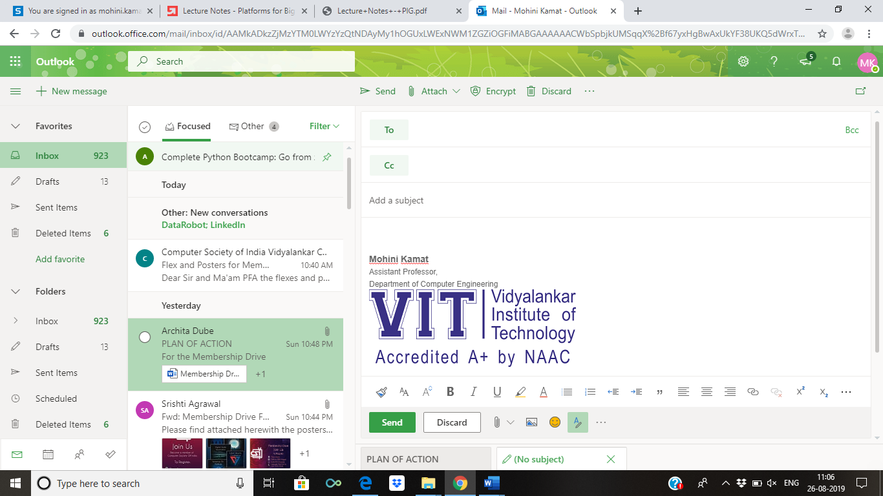

(An Autonomous Institute Affiliated to University of Mumbai)

Vidyalankar Institute of Technology

Wadala(E), Mumbai-400437

University of Mumbai

2024-25

Specimen 'B': Internal Approval Sheet

**CERTIFICATE OF APPROVAL**

This is to certify that the project entitled

**“Title of project”**

is a bonafide work of

**<First name> <Last name> (Roll No. _________)**

**<First name> <Last name> (Roll No. _________)**

**<First name> <Last name> (Roll No. _________)**

submitted to the University of Mumbai in partial fulfillment of the requirement for the award of the

degree of

**Undergraduate** in **“<Program Name>”**.

Guide

(Name)

Head of Department

(Name)

Principal

(Name)

Specimen `C': Approval Sheet

Project Report Approval for B. E.

This project report entitled (***Title***) by

1. ***<Name> (RollNo)***
2. ***<Name> (RollNo)***
3. ***<Name> (RollNo)***

is approved for the degree of ***Bachelor of Engineering in <Branch>.***

Examiners

1.---------------------------------------------

2.---------------------------------------------

Date:

Place:

Specimen `D' – Declaration

Declaration

I declare that this written submission represents my ideas in my own words and where others' ideas or words have been included, I have adequately cited and referenced the original sources. I also declare that I have adhered to all principles of academic honesty and integrity and have not misrepresented or fabricated or falsified any idea/data/fact/source in my submission. I understand that any violation of the above will be cause for disciplinary action by the Institute and can also evoke penal action from the sources which have thus not been properly cited or from whom proper permission has not been taken when needed.

|  |  |  |  |
| --- | --- | --- | --- |
| Sr. No. | Name of Student | Roll No. | Signature |
| 1. |  |  |  |
| 2. |  |  |  |
| 3. |  |  |  |

Date: